Parametric Modeling of Ultrasonic signals in Nondestructive Testing applications in Oil & Gas industry

Uvais Qidwai  Associate Professor  Department of Computer Science & Engineering  Qatar University  Email: uqidwai@qu.edu.qa  Mobile: +974 5519 8513 | Mohammed Maqbool  Research Associate & Quality Assurance Expert  Office of Academic Research  Qatar University

Abstract

Models describe relationships between measured signals. It is convenient to distinguish between input signals and output signals. The outputs are then partly determined by the inputs. Think for example of an airplane where the inputs would be the different control surfaces, ailerons, elevators, and the like, while the outputs would be the airplane's orientation and position. In most cases, the outputs are also affected by more signals than the measured inputs. In the airplane example it would be wind gusts and turbulence effects. Such “unmeasured inputs” will be called disturbance signals or noise. If we denote inputs, outputs, and disturbances by u, y, and e, respectively, the relationship can be depicted in the following figure.
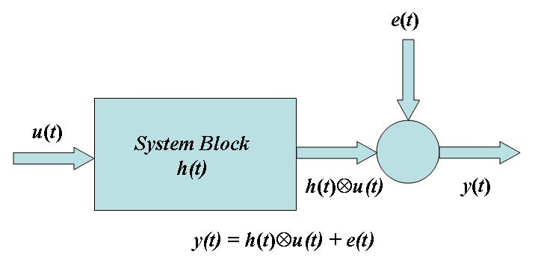
Figure 1: Input Signal u, Output Signal y, and Disturbance e within the parametric model setting.

All these signals are functions of time, and the value of the input at time t will be denoted by u(t). Often, in the identification context, only discrete-time points are considered, since the measurement equipment typically records the signals just at discrete-time instants, often equally spread in time with a sampling interval of T time units. The modeling problem is then to describe how the three signals relate to each other.
The field of system identification uses statistical methods to build mathematical models of dynamical systems from measured data. System identification also includes the optimal design of experiments for efficiently generating informative data for fitting such models as well as model reduction. A dynamical mathematical model in this context is a mathematical description of the dynamic behavior of a system or process in either the time or frequency domain. The area of system identification has been an active one in the Systems and Control Group for several decades. There is some overlap with the area signal processing, and both the senior researchers have previously also done significant amounts of research in signal processing.
Nondestructive testing or Non-destructive testing (NDT) is a wide group of analysis techniques used in science and industry to evaluate the properties of a material, component or system without causing damage. The terms Nondestructive examination (NDE), Nondestructive inspection (NDI), and Nondestructive evaluation (NDE) are also commonly used to describe this technology. Because NDT does not permanently alter the article being inspected, it is a highly-valuable technique that can save both money and time in product evaluation, troubleshooting, and research. Common NDT methods include ultrasonic, magnetic-particle, liquid penetrant, radiographic, remote visual inspection (RVI), eddy-current testing, and low coherence interferometry. NDT is a commonly-used tool in forensic engineering, mechanical engineering, electrical engineering, civil engineering, systems engineering, aeronautical engineering, medicine, and art.
In this tutorial, we will explore the applications of the System Identification within parametric modeling domain using the ultrasonic NDT signals in MATLAB environment. The general outline of the techniques presented can be used with any type of input-output measurement system for model detection and validation applications. This data-driven approach helps you describe systems that are not easily modeled from first principles or specifications, such as chemical processes and engine dynamics. It also helps you simplify detailed first-principle models, such as finite-element models of structures and flight dynamics models, by fitting simpler models to their simulated responses.
Who should attend?
The tutorial is designed around the hands-on presentation of applied mathematical techniques to the NDT domain. Anyone with keen interest in mathematical modeling, NDT for metallic structures such as pipes etc… can benefit from this tutorial. No real background is needed as well since most of the concepts will be explained from scratch.

Outline of the topics:
- Basics of 1D Parametric modeling.
- Basics of Ultrasonic NDT.
- Defect Signatures for commonly occurring defects in metals.
- Defect Signatures for Welded joints.
- Modeling of the Defect Signatures; Basic Auto Regressive Moving Average (ARMA) structure.
- Advanced Deconvolution Techniques to model Defect Signatures; Higher Order Statistics (HOS), and H∞ identification approaches.

