EQUIPMENT REQUEST FORM
Please return this completed form to EUROSIS

(This will enable us to make sure you have the equipment you require to give your presentation. Requests for special equipment AT CONFERENCE will be billed to the author)

EUROSIS Paper Code Nr:____________
Date: ___/___/____

For my presentation I will need:

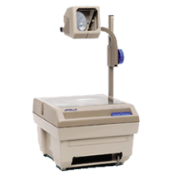______ Overhead Projector(s)

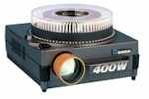______ Slide Projector(s) (see remark on slides in the speaker instructions)

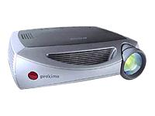______ LCD Projector(s) (SVGA)
(if 2 are needed, the 2nd one is billed to the author)

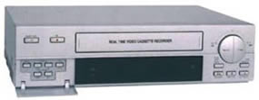______ VCR and Monitor(s) (PAL/SECAM only)

(*) Prices are available on request, and prices vary according to the number of requests.
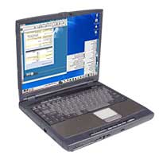(**) We HIGHLY recommend that you bring your OWN NOTEBOOK for POWERPOINT presentations
Also make sure you bring the right electrical connections when this is necessary.

Signature

