FINAL PROGRAM
 | 

2008

9-11, April 2008
Porto, Portugal

Organized by

Co-Sponsored by
 |  |  | 
 | 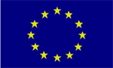  DGINFSO |  | 

Contents

General Information 4
Badges 4
Best Paper Award 6
Conference Location 4
Conference Proceedings 5
How to get there 4
Internet Connection 6
Meeting Rooms 5
Need Help? 6
Paper Legend 7
Registration 5
Social Event and Lunches 6
Tickets 5

Quick Program Overview 8
Welcome Address 11

Scientific Program 12

Wednesday, April 9 12
Thursday, April 10 17
Friday, April 11 22

Conference Locations 25

EUROSIS Info 28

General Information
  - Conference Location
The Conference itself is held at
Faculdade de Engenharia da Universidade do Porto
Rua Dr. Roberto Frias, s/n
4200-465 Porto, PORTUGAL
Tel: +351 22 508 14 00 / Fax: +351 22 508 14 40
http://www.fe.up.pt
The registration desk will be placed in the hallway in front of the meeting rooms on the ground floor. Registration will start on Wednesday at 8.00 a.m. till 5.00 p.m. On Thursday it will be from 8.30 a.m. - 4.00 p.m. with Friday registration only from 9.00 a.m.- 09.30. a.m

ALL MAPS ARE AT THE BACK OF THIS PROGRAMME
  - How to get there
By Air
Porto is served by Francisco Sá Carneiro Airport (IATA: OPO) which is located some 15km to the north-west of the city centre. The airport is served by Line E of Porto Metro, linking it to downtown Porto, pendolino trains and Estádio do Dragão, and by transfer to other urban centres of Greater Porto
STCP Buses link the airport and the city. Individual fare is €1.20. AEROBUS is a relatively fast connection between the Airport and downtown Porto, including the city's leading Hotels, every 30 minutes, from 07h45m till 19h15m. The fare is €4.00 and the ticket is valid on all STCP lines, until midnight of the same day.
By Bus
Search for a bus-stop of the bus number 6, which takes you direct to the University.
By Metro
This is the best way for reaching the conference. FEUP is about 300 m away from the final station. Take the Metro YELLOW line (Line D) in the centre of the town in the direction of "P. Universitário" and get out on this last stop.
  - Badges
Each registrant will receive a name badge upon registration. The badge must be worn in order to be admitted to the technical sessions, lunches and social event. Participants to the three events as well as the workshop participants will be designated by differently coloured dots.

General Information
  - Tickets
Extra tickets for the social event and lunches are available from the registration desk.

Price: (or equivalent in another currency) for extra tickets. All participants will be issued with tickets for lunch and the conference dinner

conference dinner:  lunch | € 50  € 20

  - Registration
The FUBUTEC-EUROMEDIA-ECEC’2008 Registration Desk will be open for information and registration:

Wednesday, April 9 8.30 a.m. to 5.00 p. m. in the hallway
Thursday, April 10 8.30 a.m. to 4.00 p. m. in the hallway
Friday, April 11 9.00 a.m. to 9.30 a.m. in the hallway

  - Conference Proceedings
Each fully paid registrant will be provided with a copy of the Conference Proceedings relevant to his or her track (printed format).
(Extra copies are available on a cash and carry basis at special rates during FUBUTEC2008-Euromedia’2008-ECEC2008)

Price: (or equivalent in another currency) for an extra copy

EUROMEDIA'2008 Proceedings | € 35
ECEC'2008 –FUBUTEC 2008 Proceedings | € 25

Other Proceedings can be ordered using the forms available at the conference.

1.7 Meeting Rooms
The meeting rooms will be designated and signposted as ROOM A (EUROMEDIA) and -B (ECEC-FUBUTEC) at the conference.

General Information

1.8 Internet Connections
Guest accounts to use the WIFI network have been requested for the duration of the conference. More information will be available at the conference.

1.9 Need Help?
Please see the conference desk for your questions

1.10 Social Events and Lunches
All registrants are invited to
The get-together party will be held on Wednesday April 9th at 5.00 p.m at the University of Porto, as well as the coffee breaks.
Lunches on Wednesday and Thursday will be served outside the University in a restaurant nearby.

The Conference Dinner
All participants are invited to the conference dinner which will be held at Tromba Rija on the 10th of April from 8.00 p.m. onwards. As we need to give an exact number of participants we would appreciate your confirmation at the desk before Wednesday evening. (for those who have as yet not done so)

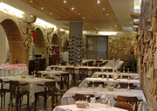 | Tromba Rija Gaia  Avenida Diogo Leite, 102  2400 - 406 - Vila Nova de Gaia - Portugal  Tel.: +351 223 743 762  Fax: +351 223 743 763  Telemóvel: +351 968 603 750  e-mail: reservasgaia@trombarija.com

1.12 Best Paper Award

During the conference the papers, which were accepted as extended papers will be judged by the committee in order to choose the best paper of the FUBUTEC’2008, EUROMEDIA’2008 and ECEC'2008 conference.

General Information
  - Paper Legend:
Each paper is designated before each paper by it’s number. This number has to be entered on the form for the best paper award

Each Room has an LCD projector and an overhead projector

ALL SESSION CHAIRPERSONS IN THIS PROGRAM ARE PROVISIONAL AND MAY BE SUBJECT TO CHANGE AT THE EVENT

THE NUMBERS NEXT TO THE PRESENTATIONS DENOTE THE PAGE-NUMBERS IN THE PROCEEDINGS. IF NO NUMBERS ARE MENTIONED THEN THIS PAPER IS NOT PUBLISHED IN THE PROCEEDINGS

THE AUTHORS WHO ARE UNDERLINED ARE NORMALLY THE PRESENTERS

PAPERS IN GREY BOXES ARE THE EXTENDED PAPERS ELIGIBLE FOR THE BEST PAPER AWARD

CHECK OUT THE OTHER EUROSIS EVENTS ON OUR WEBSITE:
http://www.eurosis.org

WEDNESDAY, 9th APRIL 2008
08.30-17.00 | REGISTRATION
09.00-10.00 | OPENING SESSION AND KEYNOTE SPEECH BY JOSE TRIBOLET MAIN ROOM
10.30-10.30 | COFFEE BREAK
 | PARALLEL SESSIONS
10.30-12.30 | ROOM A |  |  | ROOM B
10.30-12.30 | MEDICAL IMAGING  I |  |  | DATA MANAGEMENT  AND  PERFORMANCE ESTIMATION
12.30-14.00 | LUNCH BREAK
 | PARALLEL SESSIONS
14.00-15.00 |  | ROOM A |  | ROOM B
 |  | VIDEO  CODING |  | WORKFLOW  SIMULATION
15.00-15.30 |  | COFFEE BREAK
15.30-17.00 |  |  | ROOM A |  | ROOM B
 |  |  | MEDICAL IMAGING  II |  | SCHEDULING  METHODOLOGY
17.00-18.00 |  |  | GET-TOGETHER PARTY

THURSDAY, 10th APRIL 2008
08.30-16.00 | REGISTRATION
 | PARALLEL SESSIONS
09.00-10.00 | ROOM A |  | ROOM B
09.00-10.00 | VIRTUAL WORLDS  AND  WEB BASED SERVICES I |  | EMERGENCY  RISK AND SAFETY CRITICAL  SYSTEMS AND MODELS I
10.00-10.30 | COFFEE BREAK
10.30-12.30 |  | PARALLEL SESSIONS
 |  | ROOM A |  | ROOM B
 |  | DATA DETECTION  AND  MANIPULATION I |  | EMERGENCY  RISK AND SAFETY CRITICAL  SYSTEMS AND MODELS II
12.30-14.00 |  | LUNCH BREAK
 |  | PARALLEL SESSIONS
14.00-15.00 |  | ROOM A |  | ROOM B
 |  | VIRTUAL WORLDS  AND  WEB BASED SERVICES II |  | CELLULAR  NETWORKS
15.00-15.30 |  | COFFEE BREAK
 |  | PARALLEL SESSIONS
15.30-18.00 |  | ROOM A |  | ROOM B
 |  | DATA MANIPULATION  AND  APPLICATIONS |  | CASE  STUDIES
20.00-22.30 |  | CONFERENCE DINNER

FRIDAY 11TH APRIL 2008
09.00-09.30 | REGISTRATION
 | PARALLEL SESSIONS
09.00 10.00 | ROOM A |  | ROOM B
09.00 10.00 | D-TV I |  | CE IN THE  CONSTRUCTION  INDUSTRY I
10.00-10.30 | COFFEE BREAK
 | PARALLEL SESSIONS
10.30 12.30 |  | ROOM A | ROOM B
 |  | D-TV II | LOGISTICS  APPLICATIONS
12.30-12.45 |  | CLOSING SESSION AND BEST PAPER AWARD ROOM A

Friday, 9th April 2008
HALLWAY
Registration
08.30 - 17.00

MAIN ROOM (B032)
09.00 – 10.00
09.00-09.15
Opening FUBUTEC 2008 - ECEC 2008- EUROMEDIA2008 and Welcome
Welcome Address
Joao Tavares and Antonio Carvalho Brito
University of Porto
FEUP
EUROMEDIA'2008 and ECEC-FUBUTEC’2008 Conference Chairs

Wednesday, 9th April 2008
MAIN ROOM (B032)
09.15 - 10.00

Chair: Antonio Carvalho Brito, University of Porto, Portugal

KEYNOTE
Organization Self-awareness and Collective Intelligence
Professor Jose Tribolet, IST-INESC, Lisbon, Portugal

Wednesday, 9th April 2008
10.00 - 10.30
COFFEE BREAK

10.30 – 12.30
ROOM A- 11.00-12.30
MEDICAL IMAGING I
Chair: Joao Tavares, University of Porto, Porto, Portugal

WORK_03
Biomechanical Analysis of the Human Middle Ear
Fernanda Gentil, Renato Natal Jorge, Marco Parente, Pedro Martins,
Fatima Alexandre, António Ferreira and Eurico Almeida 105

WORK_04
Segmentation and Simulation of Object in Pedobarography Images
using Physical Principles
Patrícia C.T.Gonçalves, João Manuel R.S.Tavares and R.M.Natal Jorge 109

WORK_05
Tools for an Ultrasound Based 3D Bone Model Reconstruction,
Registration and Visualization System
Paulo Jorge Sequeira Gonçalves and Joaquim Moísés Fernandes 114

WORK_06
NUFFT-based Direct Fourier Methods and Regional Tomography
Silvia De Francesco and Augusto Silva 118
ROOM B- 11.00-12.30
DATAMANAGEMENT AND PERFORMANCE ESTIMATION
Chair: Christophe Roche, Universite de Savoie, Le-Bourget-du-Lac, France

FUBUTEC_06
Using Data Mining to Predict Secondary School Student Performance
Paulo Cortez and Alice Silva 29
Wednesday, 9th April 2008
FUBUTEC_08
Electronic Health Record in the TTF Framework
Elena Ciancimino and Salvatore Cannella 13

ECEC_07_03
MPSOC Design Flow Based of Performance Estimation
Kamel Smiri, Abderrazek Jemai, Nihel Chibani and Mohamed Moalla 19

ECEC_07_02
Signal-Based predictive Condition Monitoring
Egon Müller and Steffen Leischnig 27

12.30 - 14.00
LUNCH BREAK

14.00 – 15.00
ROOM A- 14.00-15.00
VIDEO CODING
Chair: Renato Natal Jorge, University of Porto, Porto, Portugal

MEDIATEC_01
High-Level Parallel H264/AVC Encoder Specification for Multiprocessor
Implementation
Hajer Krichene Zrida, Abderrazek Jemai, Ahmed Chiheb Ammari and
Mohamed Abid 31

MEDIATEC_07
Complexity Constrained Video Coding for Decoders with Limited Resources
Paulo J. Cordeiro, Juan Gomez-Pulido and Pedro A. Assunção 38

ROOM B- 14.00-15.00
WORKFLOW SIMULATION
Chair: Manuel Feliz Teixeira, University of Porto, Porto, Portugal

FUBUTEC_05
Partial Recognizing Algorithm for Verification of Workflow Processes
Armen Kostanyan and Anna Varosyan 89
Wednesday, 9th April 2008

ECEC_06_02
Modelling Time-Constrained Collaborative Workflows based on timed
Recursive Ecatnets
Kamel Barkaoui and Awatef Hicheur 95

15.00 - 15.30
COFFEE BREAK

15.30 – 17.00
ROOM A- 15.30-17.00
MEDICAL IMAGING II
Chair: Joao Tavares, University of Porto, Porto, Portugal

WORK_07
Medical Imaging in the XXI Century: the place of Functional Imaging and
Nuclear Medicine
Luís F. Metello and Lídia Cunha 123

WORK_08
Detecting Abnormalities in Endoscopic Capsule Images using Color
Wavelet Features and Feed-Forward Neural Networks
Carlos S. Lima, Daniel Barbosa, Jaime Ramos, Adriano Tavares,
Luis Carvalho and Luis Monteiro 128

WORK_02
Mapping Pelvic Floor Closure Forces Using Novel Multidirectional
Vaginal Probe
Qiyu Peng, Christos E.Konstantinou and Sadao Omata 133

ROOM B - 15.30-17.00
SCHEDULING METHODOLOGY
Chair: José Fernando Gonçalves, University of Porto, Porto, Portugal

FUBUTEC_10
A Robust What-if Bullwhip Analysis
Salvatore Cannella and Elena Ciancimino 33
Wednesday, 9th April 2008

ECEC_07_04
Holistic Metrics Applied to a Practical Supply Chain Study
António E. S. Carvalho Brito and J. Manuel Feliz-Teixeira 41

ECEC_07_06
Heuristic Approach as a Way to Improve Scheduling in ERP/APS Systems
František Koblasa, Luís S. Dias, José A. Oliveira and Guilherme Pereira 47

17.00 - 18.00
GET-TOGETHER PARTY at the University

Thursday, 10th April 2008
HALLWAY
Registration
08.30 - 16.00

09.00 – 10.00

ROOM A- 09.00-10.00
VIRTUAL WORLDS AND WEB-BASED SERVICES I
Chair: Dragos Datcu, Delft University of Technology, Delft, NL

WEBTEC_03
A Case Study of Using Web Based Services in Higher Education
Hani Alers and Charles van der Mast 5

WEBTEC_04
Providing Multimedia Recommendations Based a Markov Decision
Process inside E-Learning Platforms
Mihaela Brut, Romulus Grigoras, Vincent Charvillat and Florence Sedes 11

ROOM B - 09.00-10.00
EMERGENCY, RISK AND SAFETY CRITICAL SYSTEMS AND MODELS
Chair: Rachel Moreau, Universiteit Hasselt, Hasselt, Belgium

FUBUTEC_07
The FLOREAN System: Emergent Flood Prediction
Ivo Vondrák, Jan Martinovič, Jan Kožusznik, Svatopluk Štolfa and
Jan Unucka 55

FUBUTEC_03
Defining Project Risk Management Efficiency through Simulation
Konstantinos Kirytopoulos, Viktor Diamantas and Vrassidas Leopoulos 58
Thursday, 10th April 2008
10.00 - 10.30
COFFEE BREAK

10.30 - 12.30
ROOM A 10.30-12.30
DATA DETECTION AND MANIPULATION
Chair: Renato Natal Jorge, University of Porto, Porto, Portugal

MEDIATEC_05
On Dual View Lipreading Using High Speed Camera
Alin G. Chitu and Leon J.M. Rothkrantz 43

MEDIATEC_08
Behaviour Detection in Dutch Train Compartments
Z. Yang, A. Keur and L. J. M. Rothkrantz 52

MEDIATEC_09
Semantic Audio-Visual Data Fusion for Automatic Emotion Recognition
Dragos Datcu and Leon J. M. Rothkrantz 58

MEDIATEC_02
A Tool for turning a Series of digital Photographs into dynamic Video Flux
Philippe Codognet 69

ROOM B - 10.30-12.30
EMERGENCY, RISK AND SAFETY CRITICAL SYSTEMS AND MODELS II
Chair: Antonio Carvalho Brito, University of Porto, Porto, Portugal

ECEC_06_01
ICT Security Management and Risk Management
Jeanne Schreurs and Rachel Moreau 63

Thursday, 10th April 2008

FUBUTEC_09
Extension of Formal Concept Theory for Organization Structure Analysis
Jan Kozusznik and Ivo Vondrak 71

ECEC_01_01
Towards an Integrated Corporate Information System: Building up a Sales Product Data Model to cope with the emerging Complexity of E-Business
Christian-Andreas Schumann and Andreas Rutsch 74

ECEC_08_01
An Architecture for Collaborative Working Environments in Manufacturing Industry
Ana Correia, Cristina Grama, Dragan Stokic, Ana Campos, Rui Neves Silva and Jon Aguirre 79
12.30 - 14.00
LUNCH BREAK

14.00 - 15.00
ROOM A - 14.00-15.00
VIRTUAL WORLDS AND WEB BASED SERVICES II
Chair: Gerhard Hasslinger, Deutsche Telekom, Darmstadt, Germany

WEBTEC_05
The Automatic Identification of the Emotion Status of Web Pages
David John and Anthony C. Boucovalas 18

WEBTEC_02
DigiMem: Representing Memories in Digital Format
Georgios D. Styliaras 23

Thursday, 10th April 2008
ROOM B - 14.00-15.00
CELLULAR NETWORKS
Chair: to be announced later

ECEC_09_01
Concurrent Engineering as Means of Reducing Cellular Network Deployment Time
Naveed ur Rashid Mir and Irfan A Manarvi

ECEC_10_03
Using Concurrent Engineering for Enhancing Customer Voice Channels Capacity in a Telecom Company
Nadia Zaheer and Irfan A Manarvi

15.00 - 15.30
COFFEE BREAK

15.30 - 18.00
ROOM A 15.30-18.00
DATA MANIPULATION AND APPLICATIONS
Chair: Joao Tavares, University of Porto, Porto, Portugal

MEDIATEC_10
Efficiency of Peer-to-Peer Overlays for Content Distribution
Gerhard Haßlinger, Halldór Matthías Sigurðsson, Úlfur Ron Halldórsson and
Julian Schröder-Bernhardi 74

MEDIATEC_11
Modelling Grouping Pressures for Emergent and Self-Organizing Visual Perception
J.C. Stevens, R. Dor, Th.M. Hupkens and L.J.M. Rothkrantz 79

AUDIOTEC_01
Design and Realization of Smart Audio Systems
Zygmunt Ciota 89

Thursday, 10th April 2008

APTEC_01
Energy Saving in Intelligent Buildings via Energy Harvesting in Wireless
Sensor Networks
Lizzie Tang and Chris Guy 92

APTEC_02
A Context Aware and User Tailored Multimodal Information Generation in a Multimodal HCI Framework
Siska Fitrianie, Iulia Tatomir and Leon J.M. Rothkrantz 95

ROOM B - 15.30-17.00
CASE STUDIES
Chair: Manuel Feliz Teixeira, University of Porto, Porto, Portugal

FUBUTEC_02
Simulation Building Blocks for Business Engineering of Mobile Field Services
Tennov Simanjuntak, Yan Wang, Marijn Janssen and Alexander Verbraeck 123

ECEC_02_02
Quality Management in the Design of the Construction
José Carvalho, Jean-Claude Mangin and Gérard Sauce 128

ECEC_02_04
Definition of a Logistics Model in the Construction Industry – Case Study
Tiago Pinho, José Telhada and Maria Sameiro Carvalho 133

20.00 – 22.30
FUBUTEC-ECEC-EUROMEDIA 2008 Conference Dinner

Tromba Rija Gaia
Avenida Diogo Leite, 102
2400 - 406 - Vila Nova de Gaia - Portugal
Tel.: +351 223 743 762
Fax: +351 223 743 763
Telemóvel: +351 968 603 750
e-mail: reservasgaia@trombarija.com

Friday, 11th April 2008
HALLWAY
Registration
09.00 - 09.30

09.00 – 10.00
ROOM A - 09.00-10.00
D-TV-1
Chair: Hans Joachim Nern, T.TV.I, Dusseldorf, Germany

TV_01
Overcoming some Limits of our Information Behaviour - Choosing Rationally by Interactive Digital Broadcasting
Larry Steindler 139

TV_02
Design of Non-Collision Broadband Wireless Channel for Delivering Multimedia Information
V.M. Vishnevsky, Tatiana Atanasova and Joachim Nern 142

ROOM B - 09.00-10.00
CE IN THE CONSTRUCTION INDUSTRY
Chair: to be announced later

ECEC_10_01
Application of CE on the Supply Chain Management System of Construction Industry: A Case Study of Multinational Construction Company
Akhtar Ali and Irfan A Manarvi

ECEC_10_02
Implementation of Concurrent Engineering: A Case Study of Design & Development Group of International Turnkey Systems - Pakistan
Kamran Ahmed Malik and Irfan A Manarvi

10.00 – 10.30
COFFEE BREAK

Friday, 11th April 2008

10.30 - 12.30
ROOM A - 10.30-12.30
D-TV II
Chair: Hans Joachim Nern, T.TV.I, Dusseldorf, Germany

TV_03
CRM 2.0 - Service Delivery and Value Chain of an Interactive Media Platform
Wolfgang Rothe 146

TV_04
Survey about running international IPTV Projects – Standards, Specifications and Future Directions
Jan Elsner 149

TV_05
Semantic Television – a New Vision or a New Business Case Approach? Interactive Media Based Edutainment Realized as WEB 3.0 Environment
H Joachim Nern, Tatiana Atanasova and Georg Jesdinsky 153

TV_06
Short overview about Portlet Technology for Realization of Interactive Broadcast Platforms
Axel Doussier 157

TV_07
Digital Broadcast Environment using Web Service Technology -
New Approaches for Fuzzy Content Detection and Service Distribution
H Joachim Nern, V.M. Vishnevsky and Tatiana Atanasova 159

ROOM B - 10.30-12.00
LOGISTICS APPLICATIONS
Chair: Manuel Pina Marques, University of Porto, Porto, Portugal

ECEC_02_01
Assessment of Delivery Strategies by applying lexicographic Optimization and Design of Experiments: A Case Study
Herminia I. Calvete, Carmen Gale, Maria-Jose Oliveros,
and Belen Sanchez-Valverde 103

Friday, 11th April 2008

ECEC_02_03
A Linear Programming Model for the Storage Location Assignment Problem – A case Study
Carla Geraldes, Sameiro Carvalho and Guilherme Pereira 111

ECEC_02_06
Using 3-D Simulation in an Industry Internal Logistic Process
Vik Pavel, Luís S. Dias, José A. Oliveira and Guilherme Pereira 116

12.30 - 12.45
ROOM A 12.30 - 12.45
Closing Session and Best Paper Award
Chairs: Antonio Carvalho Brito, Joao Tavares and Manuel Feliz Teixeira

SEE YOU ALL NEXT YEAR AT FUBUTEC-ECEC-EUROMEDIA’2009 IN APRIL 2009

Most probable location PATRAS, Greece
(Confirmation to follow)
Conference Site Maps

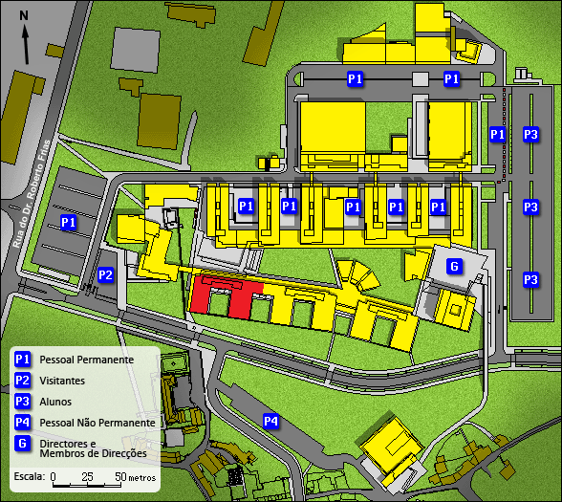
FEUP- University of Porto Campus
and Conference Location
Conference Site Maps

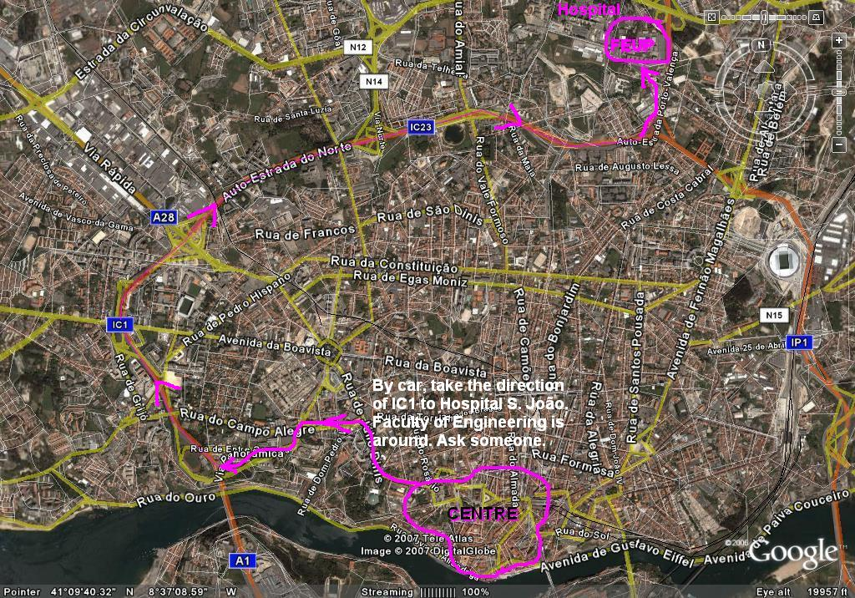
How to reach the University by Car
And on the next page by metro

Conference Site Maps

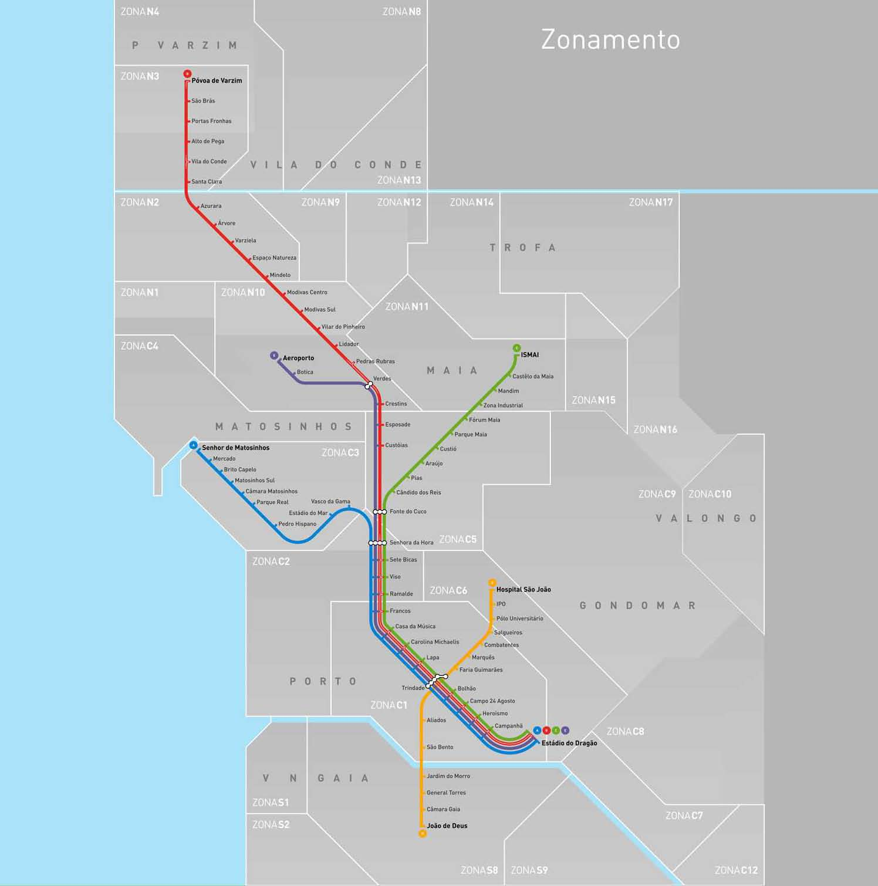

EUROSIS was borne out of discussions with the European Community to set up a new kind of Society, which would be project-driven instead of driven by pure membership and conferences.

The aim of EUROSIS is to set up topic related Technical Committees which will link directly to European Projects in the field of computer simulation and related areas and to act as a knowledge pool for future European Networks of Excellence, like MOSAIC.

If you would like to receive more information about EUROSIS, please contact

Philippe Geril
EUROSIS-ETI
Greenbridge NV
Wetenschapspark 1
Plassendale 1
B-8400 Ostend Belgium
Tel: +32.59.255330
Fax: +32.59.255339
Email: Philippe.Geril@eurosis.org

Please send me info on EUROSIS:
Name:
Address:

Telephone
Fax:
Email:

