Final Program
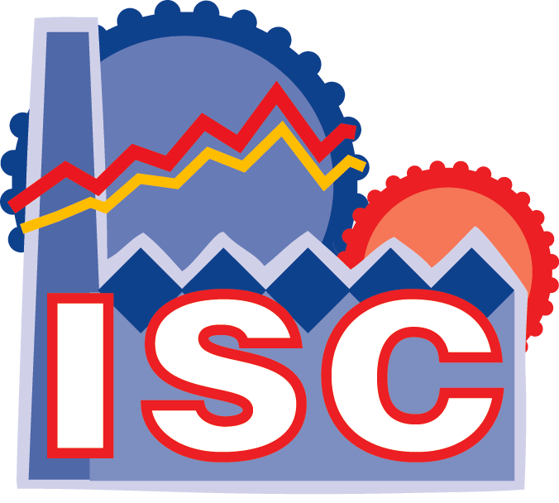
11-13 June 2007



Organized by

Sponsored by
 |  |  | 
 |  |  | 

Contents

General Information 4
Conference Location 4
How to get there 4
Badges 4
Tickets 5
Registration 5
Conference Proceedings 5
Meeting Rooms 5
Internet Connection 6
Need Help? 6
Social Event and Lunches 6
Best Paper Award 7
Paper Legend 7

Quick Program Overview 8
Welcome Address 11

Scientific Program 11

Monday, June 11 11
Tuesday, June 12 18
Wednesday, June 13 23

Exhibition 27

Conference Locations 28

EUROSIS Info 30

General Information
  - Conference Location
The Conference itself is held at
Delft University of Technology
Faculty of Mechanical, Maritime and Materials Engineering
Mekelweg 2
2628 CD Delft, The Netherlands
The registration desk will be placed in the hallway in front of the meeting rooms on the first floor. Registration will start on Monday at 8.30 a.m. till 5.00 p.m. On Tuesday it will be from 8.30 a.m. - 5.00 p.m. with Wednesday registration only from 9.00 a.m.- 09.30. a.m.

ALL MAPS ARE AT THE BACK OF THIS PROGRAMME
  - How to get there
By Air
When arriving in the Netherlands, you will most likely arrive at Shiphol Airport near Amsterdam. At the airport itself you can transfer to the rail network. You can either take a train to The Hague/Rotterdam and change trains at The Hague Holland Spoor or go on to Rotterdam, change trains there and return to Delft. In both cases the distance to Delft is about 20 mins.

By Bus
The TU Campus can be reached from Delft Station with the district lines 69, 121 or 129.
By Car
The TU Campus is easily accessible by car via the A13, exit Delft/Pijnacker and exit Delft Zuid/TU-wijk.

  - Badges
Each registrant will receive a name badge upon registration. The badge must be worn in order to be admitted to the technical sessions, lunches and social event.

General Information
  - Tickets
Extra tickets for the social event and lunches are available from the registration desk.

Price: (or equivalent in another currency) for extra tickets. All participants will be issued with tickets for lunch and the conference dinner

conference dinner:  lunch | € 60  € 30

  - Registration
The ISC’2007 Registration Desk will be open for information and registration:

Monday, June 11 8.15 a.m. to 5.00 p. m. in the hallway
Tuesday, June 12 8.30 a.m. to 5.00 p. m. in the hallway
Monday, June 13 8.45 a.m. to 9.30 a.m. in the hallway

  - Conference Proceedings
Each fully paid registrant will be provided with a copy of the Conference Proceedings (printed format).
(Extra copies are available on a cash and carry basis at special rates during ISC-2007)

Price: (or equivalent in another currency) for an extra copy

ISC'2007 Proceedings | € 50
Other Proceedings –see price list at desk

Other Proceedings can be ordered using the forms available at the conference.

1.7 Meeting Rooms
The meeting rooms will be designated and signposted as ROOM A-B-C at the conference.
Plenary Session: ROOM A (next to Faculty Room)
ROOM A= ZAAL E
ROOM B= ZAAL F
ROOM C= ZAAL R (Tuesday and Wednesday) -S (Monday)
Closing Session: ZAAL E or F
General Information

1.8 Internet Connections
Guest accounts to use the WIFI network have been requested for the duration of the conference. More information will be available at the conference.

1.9 Need Help?
Please see the conference desk for your questions

1.10 Social Events and Lunches
All registrants are invited to
The get-together party on Monday June 11th at 5.00 p.m.
Lunches on Monday and Tuesday and Coffee Breaks will be served at the Delft University of Technology in the room at the back of the main corridor, which links the meeting rooms.

The Conference Dinner
All participants are invited to the conference dinner which, will be held at the Teeschenkerij Rieten Dak on the 12th of June from 7.00 p.m. onwards. As we need to give an exact number of participants we would appreciate your confirmation at the desk before Monday evening. (for those who have as yet not done so) | 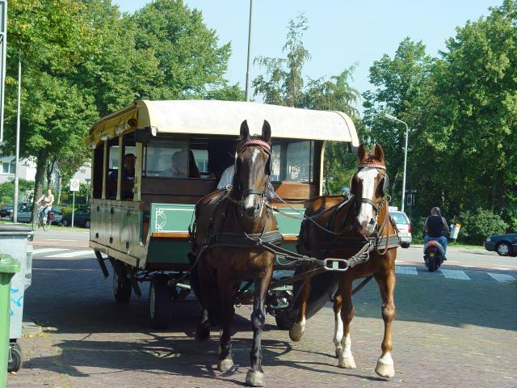  Participants will be able to go there and back by horse tram.

The Conference Visit and Industrial Design Exhibition
On the morning of Tuesday the 12th of June, participants will be taken to visit a couple of labs at Delft University of Technology. The visit will last 1 hour and will visit the labs of maritime technology.

During the conference the faculty where we are, will organize together with the “Leeghwater” society an industrial design exhibition and competition –theme this year is Bicycles-, from 11.00 am onwards. After the exhibition, there will be free drinks for everyone and a show given by the Dutch rapper Ali.B. This will coincide with the end of sessions on Day 2.

General Information

1.12 Best Paper Award

During the conference the papers, which were accepted as extended papers will be judged by the committee and participants in order to choose the best paper of the ISC'2007 conference.
  - Paper Legend:
Each paper is designated before each paper by it’s number. This number has to be entered on the form for the best paper award

Every Room has an LCD projector and an overhead projector

ALL SESSION CHAIRPERSONS IN THIS PROGRAM ARE PROVISIONAL

THE NUMBERS NEXT TO THE PRESENTATIONS DENOTE THE PAGE-NUMBERS IN THE PROCEEDINGS. IF NO NUMBERS ARE MENTIONED THEN THIS PAPER IS NOT PUBLISHED IN THE PROCEEDINGS

THE AUTHORS WHO ARE UNDERLINED ARE NORMALLY THE PRESENTERS

PAPERS IN GREY BOXES ARE THE EXTENDED PAPERS ELIGIBLE FOR THE BEST PAPER AWARD

CHECK OUT THE OTHER EUROSIS EVENTS ON OUR WEBSITE:
http://www.eurosis.org

MONDAY, 11th JUNE 2007
08.15-17.00 | REGISTRATION
09.00-09.15 | OPENING SESSION IN THE MAIN ROOM –ZAAL A
09.15-10.00 | KEYNOTE ADDRESS BY BERT VAN BEEK, EINDHOVEN UNIVERSITY OF TECHNOLOGY
10.00-10.30 | COFFEE BREAK
10.30-12.30 | PARALLEL SESSIONS
 | ROOM A | ROOM B | ROOM C
 | COMPLEX  SYSTEMS  SIMULATION  METHODOLOGY | PRODUCTION  SCHEDULING  AND  MATERIALS HANDLING | NUCLEAR  ENERGY  AND  PETROCHEMICAL ENGINEERING
12.30-14.00 | LUNCH BREAK
14.00-15.00 | PARALLEL SESSIONS
 | ROOM A | ROOM B | ROOM C
 | STEEL  MANUFACTURING  SIMULATION  I | SCHEDULING  OPTIMIZATION  AND  ANALYSIS | PRODUCT  PRESENTATION
15.00-15.30 | COFFEE BREAK
15.30-17.30 | PARALLEL SESSIONS
 | ROOM A | ROOM B | ROOM C
 | STEEL  MANUFACTURING  SIMULATION  II | TUTORIAL | COMMUNICATIONS  MODELLING  AND  SIMULATION

17.30 GET-TOGETHER-PARTY

TUESDAY, 12th JUNE 2007
08.30-17.00 | REGISTRATION
09.00-10.00 | PARALLEL SESSIONS
 | ROOM A | ROOM B | ROOM C
 | KRIGING  METHODOLOGY | URBAN  AND  MOTORWAY TRAFFIC  SIMULATION | VISIT OF DELFT UNIVERSITY RESEARCH LABS
10.00-10.30 | COFFEE BREAK
10.30-12.30 | PARALLEL SESSIONS
10.30-12.30 | ROOM A | ROOM B | ROOM C
10.30-12.30 | SOFTWARE MODEL  DEVELOPMENT  AND  HUMAN BEHAVIOURAL  MODELLING | TRAFFIC  AND  LOGISTICS  CASE STUDIES | MODELLING  OF  TEXTILE  STRUCTURES
12.30-14.00 | LUNCH BREAK
14.00-15.00 | PARALLEL SESSIONS
14.00-15.00 | ROOM A | ROOM B | ROOM C
14.00-15.00 | META-KNOWLEGDE  SIMULATION  I | AUTOMOTIVE  SIMULATION | MODELLING  FOR  EVALUATION  AND PREDICTION
15.00-15.30 | COFFEE BREAK
15.30-17.30 | PARALLEL SESSIONS
15.30-17.30 | ROOM A | ROOM B | ROOM C
15.30-17.30 | META-KNOWLEGDE  SIMULATION  II | SERVO ENGINE  AND  ERROR DETECTION | SMART TEXTILES  MODELLING  AND DEVELOPMENT
17.00-18.00 | EHIBITION VISIT AND DRINKS
19.00 – 22.00 | CONFERENCE DINNER

WEDNESDAY, 13th JUNE 2007
08.45-09.30 | REGISTRATION
09.00 10.00 | PARALLEL SESSIONS
 | ROOM A | ROOM B | ROOM C
 | TUTORIAL | VIRTUAL  MANUFACTURING  SIMULATION | PRODUCTION  EFFICIENCY  IMPROVEMENT
10.00-10.30 | COFFEE BREAK
10.30 12.00 | PARALLEL SESSIONS
 | ROOM A | ROOM B | ROOM C
 | ROBOT NAVIGATION  SIMULATION  AND  VALIDATION | PRODUCT DESIGN  WITH  VIRTUAL REALITY | MILITARY OPTIMIZATION  AND  RISK ASSESSMENT
12.00-12.15 | CLOSING SESSION AND BEST PAPER AWARD

Monday, 11th June 2007

HALLWAY
Registration
08.15 - 17.00

MAIN HALL
09.00 – 10.00
Opening ISC2007 and Welcome
Welcome Address
Professor Lodewijks
Delft University of Technology
ISC'2007, General Conference Chair

Jaap Ottjes and Hans Veeke
Delft University of Technology
ISC'2007, Program Chairs

09.15 – 10.00
KEYNOTE SPEECH
Chair: Jaap Ottjes, Delft University of Technology, Delft, NL

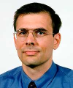

Simulation and Verification of Timed and Hybrid Dynamical Systems
dr.ir. Bert D.A. van Beek

Monday, 11th June 2007
10.00 - 10.30
COFFEE BREAK

10.30 – 12.30
ROOM A- 10.30-12.30 COMPLEX
COMPLEX SYSTEMS SIMULATION METHODOLOGY
Chair: Frans Sopers, Delft University of Technology, Delft, NL

COMPLEX-02
Finding Relationships that are Functions
William Conley 61

COMPLEX-05
A Discrete Model for the Dynamics of Sandpile Surfaces
Ignacio Garcia-Fernandez, Marta Pla-Castells and Rafael J. Martinez-Dura 64

METH-07
Secondary Nucleation Study of Sucrose Crystallization: Experiments and Modeling
S. Ouiazzane, B. Messnaoui, J. Wouters and T. Bounahmidi 467

ELEC-02
Algorithms for Rare Event Simulation with Markov Chains
Dimitar Radev and Izabella Lokshina 69

ROOM B- 10.30-12.30 PROD
PRODUCTION SCHEDULING AND MATERIALS HANDLING
Chair: J. Manuel Feliz Teixeira, University of Porto, Porto, Portugal

MANUF-02
Implementing an Evolutionary Algorithm for Production Scheduling in
a Cardboard Corrugated Fabrication Plant
Fabian Vargas-Nieto, Jairo R. Montoya-Torres and German Velasquez 215

LOGIS-09-MANUF
Design and Implementation of a Bi-Objective EA-Based Scheduling
Strategy: Case Study in Thermal Printed Label Manufacturing
Fabian Vargas-Nieto and Jairo R. Montoya-Torres 219
Monday, 11th June 2007
MANUF-04
Simulating Wireless Monitoring in Automated Maintenance of Belt Conveyor Systems
S. Güngen, A. Lopez de la Cruz, H. P.M. Veeke and G. Lodewijks 223

MANUF-01
Performance Evaluation of Lot Dispatching and Automated Material Handling Approaches by Discrete Event Simulation
René Drießel and Lars Mönch 230

ROOM C- 10.30-12.30 ENERGY
NUCLEAR ENERGY AND PETROCHEMICAL ENGINEERING
Chair: Dick Mensch, Delft University of Technology, Delft, NL
ENERG-03
Using Web Services in Nuclear Power Plant Simulators
José A. Cortés, Manuel Díaz, Daniel Garrido, Isabel Parrado and
Enrique Soler 363

ENERG-01
Instrumentation and Control System Renewal using Simulation
at PAKS Nuclear Power Plant
János Sebestyén Jánosy 368

ENERG-02
Real-Time System for a Heavy Water Detritiation Plant
Florin Hartescu 373

PET-01
Using a Generic Methodology to Develop a Simulation Model of a Petrochemical Plant
Martin Albertyn and Paul S Kruger 377

12.30 - 14.00
LUNCH BREAK

Monday, 11th June 2007
14.00 – 15.00
ROOM A- 14.00-15.00 STEEL
STEEL MANUFACTURING SIMULATION I
Chair: Adriana Lopez de la Cruz, Delft University of Technology, NL

MANUF-12
Process Rules for Sheet Metal Hydroforming
Antonio Del Prete, Teresa Primo, Gabriele Papadia and Barbara Manisi 109

MANUF-07
Process Automation Tools development for Sheet Metal Hydroforming Simulation
Antonio Del Prete, Alfredo Elia, Teresa Primo and Barbara Manisi 114

ROOM B- 14.00-15.00 SCHED
SCHEDULING OPTIMIZATION AND ANALYSIS
Chair: Joel Colloc, Universite Lumiere Lyon 2, Lyon, France

LOGIS-01
Improving a Call Center Performance at a Telecommunication Company
Athanassios N. Avramidis, Michel Gendreau, Pierre L’Ecuyer and
Ornella Pisacane 255

HOSLOGIS-03
Modelization and analysis of trajectories in medical simulations
François-Xavier Magaud, Claude Dussart and Claude Petit 264

ROOM C- 14.00-15.00 PRODUCT
PRODUCT PRESENTATION
Chair: Matteo Palmonella, ESI.

ESI and its solutions for Virtual Prototyping and Virtual Manufacturing
Matteo Palmonella, ESI GROUP

Monday, 11th June 2007
15.00 - 15.30
COFFEE BREAK

15.30 - 17.00
ROOM A- 15.30-17.30 STEEL
STEEL MANUFACTURING SIMULATION II
Chair: Hans Veeke, Delft University of Technology, Delft, NL

MANUF-08
Detailed Model of Spot Welded Joints to simulate the Dynamical Failure of Car Assemblies
Emmanuel H.J. Lamouroux, Daniel Coutellier and Falko Seeger 119

ENG-01
A Study on the Development of High Precision Cam Profile CNC Grinding Machine with Maximum Grinding Speed to obtain Constant Surface Roughness
Younghwa Roh, Sangheon Lim, Sunghwan Ahn, Choonman Lee, Jongyun Jung
and Sangdae Yoon 131

ENG-06
Advanced Kinematic Geometrical Model of Grinding Processes
Blazej Balasz and Tomasz Królikowski 137

ENG-02
A Study on the effect of Surface Roughness and cutting Force in MQL End Milling
Su Hyun Park, Jong Yun Jung, Choon Man Lee and Young Kug Hwang 142

ROOM B- 15.30-17.30 WORKSHOP
WORKSHOP
Chair: J. Manuel Feliz Teixeira, University of Porto, Porto, Portugal

TUT
scMod/Sim.exe: For Supply Chain Modelling and Simulation
J. Manuel Feliz Teixeira 5
Monday, 11th June 2007
ROOM C- 15.30-17.00 ELEC
COMMUNICATIONS MODELLING AND SIMULATION
Chair: Lars Mönch, FernUniversität Hagen, Hagen, Germany

METH-01-ELEC
Modular Approach Based Decision Support for Communication Systems
Calin Munteanu, Simona Caramihai and Janetta Culit 345

METH-04-TRAF
Combination and Interworking of Four Modelling Methods for Infocommunications and Business Process Modelling
Gábor Lencse and László Muka 350

ELEC-01
Modeling and Simulation of Self-Similar Teletraffic
Dimitar Radev and Izabella Lokshina 355

ORGANIZATION UPDATE SESSION 17.00-17.30

17.30 -18.30

GET-TOGETHER PARTY
In the Main Hall

Tuesday, 12th June 2007
HALLWAY
Registration
08.30 - 17.00

09.00 – 10.00
ROOM A- 09.00-10.00 METH
KRIGING METHODOLOGY
Chair: Janos Sebestyen Janosy, MTA-KFKI, Budapest, Hungary

COMPLEX-07
Performance Evaluation of the Evolution Control in design Optimization
assisted by Kriging Surrogates
Gabriella Dellino, Paolo Lino, Carlo Meloni, and Alessandro Rizzo 49

METH-09
Modeling of water pressure distribution in water nets using the kriging
algorithms
Lucyna Bogdan and Jan Studzinski 52

ROOM B- 09.00-10.00 TRAF
URBAN AND MOTORWAY TRAFFIC SIMULATION
Chair: Pierre l’Ecuyer, Université de Montreal, Montreal, Canada

LOGIS-06
Urban Traffic Systems - Proposition and application of generic components
Michelle Chabrol, Michel Gourgand, Damien Hostin and Patrice Leclaire 273

LOGIS-02
Neural Network Microsimulation of Motorway Traffic
Abs Dumbuya, George Lunt, Jill Weekley, Anna Booth and Andrew Lewis 279

ROOM C- 09.00-10.00 VISIT
VISIT OF DELFT UNIVERSITY RESEARCH FACILITIES

Tuesday, 12th June 2007
10.00 - 10.30
COFFEE BREAK

10.30 - 12.30
ROOM A- 10.30-12.30 COMPLEX
SOFTWARE MODEL DEVELOPMENT AND HUMAN BEHAVIOURAL MODELLING
Chair: Marc Duinkerken, Delft University of Technology, Delft, NL

COMPLEX-01
A Component Framework for the Development of Complex Simulators
José A. Cortes, Jose A. Dianes, Manuel Díaz, Daniel Garrido and
Enrique Soler 77

COMPLEX-03
Modeling Complex Systems using the Web Ontology Language (OWL)
Tobias Lehmann and Andreas Karcher 82

WEB-03
Multimodal Web based system for human emotion recognition
Dragos Datcu and L.J.M. Rothkrantz 91

METH-03
Christiansen Grammar Evolution for the Modelling of Psychological Processes
Emilio del Rosal, Alfonso Ortega, Manuel Alfonseca and Marina de la Cruz 99

ROOM B- 10.30-12.00 TRAF
TRAFFIC AND LOGISTICS CASE STUDIES
Chair: Michel Gourgand, Université Blaise Pascal, Aubiere, France

LOGIS-04
Simulation Modelling of Airport Passenger Operations: An Improvement Case Study
Martin S. Barber and Peter Durie 289

Tuesday, 12th June 2007

LOGIS-07
Bulk Terminal modelling and simulation
Jaap A. Ottjes, Gabriel Lodewijks and Dingena L.Schott 294

HOSLOGIS-04
Simulation of a Holding Unit between First Aid Center and Specialty Wards: A Case Study
A.C. van Bruggen, H.P.M. Veeke, G. Lodewijks and F.K. van Lambalgen 299

ROOM C- 10.30-12.30 TEX
MODELLING OF TEXTILE STRUCTURES
Chair: Pascal Bruniaux, GEMTEX- ENSAIT, Roubaix, France

TEX-02
INTER Fiber Frictional Model in The Cotton Sliver
Shahram Nowrouzieh, Artan Sinoimeri, Jean-Yves Drean, Richard Frydrich and Jean-Paul Gourlot 409

TEX-05
Finite Element Modelling of the Warp Knitted Structure
Argyro Kallivretaki, Savvas Vassiliadis, Mirela Blaga
and Christopher Provatidis 413

TEX-06
Introduction to Modelling of Virtual Garment Design in 3D
Agnieszka Cichocka, Pascal Bruniaux and Vladan Koncar 420

VIR-03-TEX
Interactive Visualisation of Simulated Nonwoven Fabrics
Carlo Moritz Göllner, Stefan Wundrak, Alvaro Segura, Aitor Moreno
and André Stork 426

12.30 - 14.00
LUNCH BREAK

Tuesday, 12th June 2007
14.00 - 15.00
ROOM A- 14.00-15.00 METH
META-KNOWLEDGE SIMULATION I
Chair: Adriana Lopez de La Cruz, Delft University of Technology, NL

METH-05
Hard and Soft Approaches in a Simulation Meta-Methodology
László Muka and Gábor Lencse 17

HOSLOGIS-05
A Clinical Decision Metaknowledge Model
Joël Colloc, Marie-Hélène Cuvelier and Peter Summons 23

ROOM B- 14.00-15.00 AUTO
AUTOMOTIVE MANUFACTURING SIMULATION
Chair: Hans Veeke, Delft University of Technology, Delft, NL

AUTO-02
A Concept of an Integrated Suspension Control Logic Architecture and its Testing
Grzegorz Slaski 201

AUTO-03-MIL
Numerical Simulation of Vehicle Platoon Aerodynamics
Marek Maciejewski and Ewa Narbuntowicz 206

ROOM C- 14.00-15.00 TEX
MODELLING FOR EVALUATION AND PREDICTION
Chair: Pascal Bruniaux, GEMTEX- ENSAIT, Roubaix, France

TEX-09
Userfriendly Permeability predicting Software for Technical Textiles
B. Verleye, G. Morren, S.V. Lomov, H. Sol and D. Roose 455

TEX-10
Modelling the Agility in the Apparel Industry
Antonela Curteza and Adela Florea 459
Tuesday, 12th June 2007
15.00 - 15.30
COFFEE BREAK

15.30 – 17.30
ROOM A- 15.30-17.00 METH
METAKNOWLEDGE SIMULATION II
Chair: Gabor Lencse, Szechenyi Istvan University, Gyor, Hungary

HOSLOGIS-01
Medical and Pharmaceutical Experiences: Knowledge Discovery with Strategy by Vote
Claude Dussart, François-Xavier Magaud and Claude Petit 30

HOSLOGIS-02
Experimental Study with Metrics Indicating the Interpretation of Clinical Guidelines
Peter F. Summons and Joël Colloc 35

METH-10
Discrete and Stochastic Simulation and Response Surface Methodology:
An Approach to a varying experimental Error
Lucia Cassettari, Roberto Mosca, Roberto Revetria and Flavio Tonelli 40

ROOM B- 15.30-17.30 ROBOT
SERVO ENGINE AND ERROR DETECTION SIMULATION
Chair: Dingena Schott, Delft University of Technology, Delft, NL

ENG-03
Informatics platform for determining the dynamic performances of a two stages servo valve
Alexandru Marin, Petrin Drumea, Marian Blejan and Ioana Ilie 151

ENG-04
Optimization of Electro-Hydraulic Systems using Mechatronic Concepts
Alexandru Marin, Petrin Drumea and Adrian Mirea 155

MANUF-03
Online Errors Identification in Multi-Axis Machines for Adaptive Compensation
Abderrazak El Ouafi and Nourredine Barka 161
Tuesday, 12th June 2007

ROBO-09
On-line Simulation Based Fault Detection for a Hydraulic Driven Industrial Robot
C. Angeli and A. Chatzinikolaou 165

ROOM C- 15.30-17.00 TEX
SMART TEXTILES MODELLING AND DEVELOPMENT
Chair: Pascal Bruniaux, GEMTEX- ENSAIT, Roubaix, France

TEX-01
Textronics Device for Measuring the Breathing Rhythm
Janusz Zieba and Michal Frydrysiak 437

TEX-03
Textile Magnetic Core
Janusz Zieba 442

TEX-04
Textronic Model of Clothing considering changes in its Thermoinsulating Properties
Michal Frydrysiak, Stefan Ziegler and Krzysztof Gniotek 447

AFTER THE SESSIONS VISIT TO THE INDUSTRIAL DESIGN EXHIBITION

Two horsetrams have been rented to bring the participants to the dinner location. Departure on the main market square accross the Town Hall at about 18.45 and return to the city centre at 22.00 and 22.15 hours.

CONFERENCE DINNER – 19.00 -22.00

The conference dinner will be held at  Teeschenkerij Het Rieten Dak  Middelweg 3  2616 LV Delft  Tel. +31.15-2124714  Fax. +31.15-2148144  email: info@hetrietendak.nl | 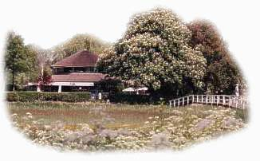
Wednesday, 13th June 2007
HALLWAY
Registration
08.45 - 09.30

09.00 – 10.00
ROOM A- 09.00-10.00 TUTORIAL
TUTORIAL
Chair: J. Manuel Feliz Teixeira, University of Porto, Porto, Portugal

TUT
scMod/Sim.exe: For Supply Chain Modelling and Simulation
J. Manuel Feliz Teixeira 5

ROOM B- 09.00-10.00 VIR
VIRTUAL MANUFACTURING SIMULATION
Chair: Hans Veeke, Delft University of Technology, Delft, NL

VIR-01
A Virtual Manufacturing Environment for Interoperability Testing
Charles R. McLean, Sanjay Jain, Andreas Craens and Deogratias Kibira 331

MANUF-10
A Software Simulator for Steel Plant
Osvaldo Barbarisi, Carmen Del Vecchio, Giovanni Palmieri and
Alessandra Parisio 338

ROOM C- 09.00-10.00 MANUF
PRODUCTION EFFICIENCY IMPROVEMENT
Chair: Lars Mönch, FernUniversität Hagen, Hagen, Germany

ELEC-03
Accelerating SoC Design using SysML and SystemC1
Waseem Raslan and Ahmed Sameh 247
Wednesday, 13th June 2007

MANUF-06-ELEC
Simulation based Planning of Capacity Increase for the Production of Lithium Polymer Batteries
Claus-Burkard Boehnlein and Christian Sahr 242

10.00 - 10.30
COFFEE BREAK

10.30 - 12.30
ROOM A- 10.30-12.30 ROBOT
ROBOT NAVIGATION AND VALIDATION
Chair: Leon Rothkrantz, Delft University of Technology, Delft, NL

ROBO-01
Hybrid Neuro-Fuzzy System for Mobile Robot reactive Navigation
Munaf S. N. Al-Din and Ahmed A. Abdullah 173

ROBO-07
Particle filter-based localization of simulated mini-rovers with low-cost IR sensors
Fabrizio Abrate, Basilio Bona and Marina Indri 178

ROBO-02
Modelling and Validation of a 1DOF Arm Powered by Pneumatic Muscles
Aron Pujana-Arrese, Javier Arenas, Leire Maruri, Ana Martinez-Esnaola
and Joseba Landaluze 185

ROBO-04
Modeling, Stress Analysis and Design of an Underwater Remotely Operated Vehicle (ROV)
Ahmad Bagheri, Shahed Aliakbar and Salar Basiri 193

Wednesday, 13th June 2007
ROOM B- 10.30-12.30 VIR
PRODUCT DESIGN WITH VR
Chair: Marc Duinkerken, Delft University of Technology, Delft, NL

MANUF-11
Model and simulation of a Gas Cookers Assembly Line: Performance
Analysis and Suggestions to increase Efficiency
Giovanni Andrioli and Giorgio Romanin-Jacur 239

VIR-05
Virtual Ergonomics Analysis to Validate Product Design
Giorgio Colombo, Demis Bronco, Caterina Rizzi and Daniele Regazzoni 311

VIR-07
A Simulator of Agent-Based Household Appliances
Konrad Steblovnik and Damjan Zazula 316

VIR-02
Visualization for an Augmented Reality Construction Machinery Simulator
Alvaro Segura, Aitor Moreno, Gino Brunetti and Thomas Henn 324

ROOM C- 10.30-12.00 RISK
MILITARY OPTIMIZATION AND RISK ASSESSMENT
Chair: Jaap Ottjes, Delft University of Technology, Delft, NL

MIL-01
Using a Simulation Model to determine the optimum Number of Pilots
in an Air Force
Martin Albertyn and Stephen D. Trichard 387

MIL-02
Scenario Modeling in Environmental Monitoring and Civil Protection Applications
Alexander Sabov, Gerhard Schreck and Jörg Krüger 395

MIL-03-LOGIS
Safety/Security Management Model supporting Hazard Identification
and Risk Assessment in the Air Traffic Services
Tomas Feglar 400
Wednesday, 13th June 2007

ROOM A 12.30 - 12.45 BEST PAPER
CLOSING SESSION AND BEST PAPER AWARD
Chair:

SEE YOU ALL
JUNE 9-11, 2008
FOR ISC’2008
IN LYON, FRANCE

General Conference Chair:
Joel Colloc, Universite de Lyon

Track proposals and tutorial proposals can be sent in by August 15th, 2007
Exhibition
During the conference participants will be able to see the products of


ESI Group is the world's leading company for the numerical simulation of prototype and manufacturing process engineering in applied mechanics. The key to ESI Group's success is the use of realistic material physics, providing "as good as real" virtual solutions, in order to replace the lengthy trial and error processes on real prototypes.
ESI Group has developed an entire suite of coherent industry-oriented applications to realistically simulate a product's behavior during certification testing, to fine tune the manufacturing processes in synergy with the desired product performance, and to evaluate the operational or accidental environment's impact on product usage. ESI Group's product portfolio, which has been industrially validated and combined in multi-trade value chains, represents a unique collaborative, virtual engineering solution, known as the Virtual Try-Out Space (VTOS), enabling a continuous improvement on the virtual prototype

Conference Site Maps

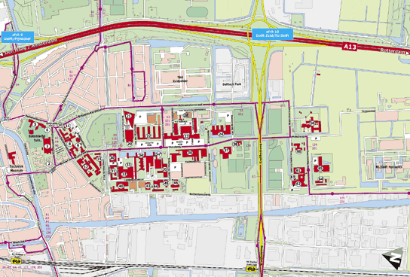

Delft University of Technology
Campus

Conference Site Maps

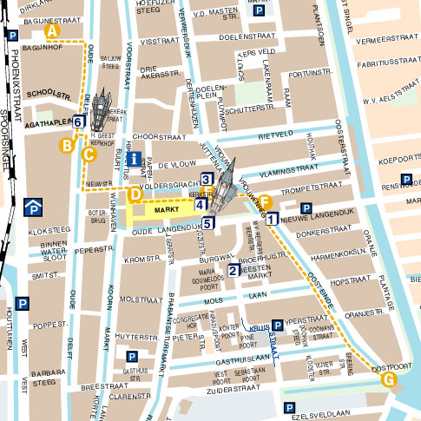

Delft City Centre

EUROSIS was borne out of discussions with the European Community to set up a new kind of Society, which would be project driven instead of driven by pure membership and conferences.

The aim of the new Society will be to set up topic related Technical Committees which will link directly to European Projects in the field of computer simulation and related areas and to act as a knowledge pool for future European Networks of Excellence, like MOSAIC.

If you would like to receive more information about EUROSIS, please contact

Philippe Geril
EUROSIS-ETI
Ghent University
Faculty of Engineering
Dept. of Industrial Mgmt.
Technologiepark 903
Campus Ardoyen
B- 9052 Ghent-Zwijnaarde
Belgium
Tel: +32.9.264.55.09
Fax: +32.9.264.58.25
Email: Philippe.Geril@eurosis.org

Please send me info on EUROSIS:
Name:
Address:

Telephone
Fax:
Email:

