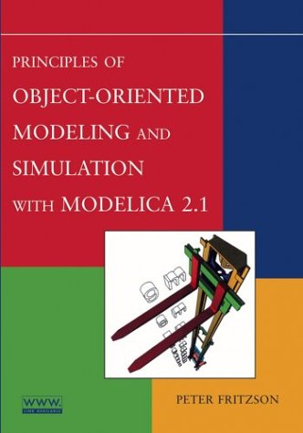
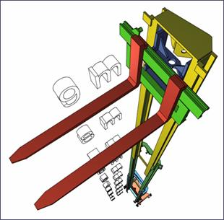

Modelica Tutorial at ISC’2014 Conference
Introduction to Modeling, Simulation, Debugging, and Optimization with Modelica using OpenModelica Debugging, Optimi
Hands-on exercises using OpenModelica—Bring Laptop
Short intro to Debugging and Dynamic Optimization.
Wednesday, June 11, 2014

The tutorial has the following goals
• Being easily accessible for people who do not previously have a background in modeling and simulation.
• Introducing the concepts of physical modeling, object-oriented modeling and component-based modeling and simulation.
• Demonstrating modeling examples from several application areas.
• Providing opportunity for hands-on exercises with the OpenModelica open-source implementation of Modelica and a graphic user interface

The tutorial is based on Peter Fritzson’s book:

Principles of Object-Oriented Modeling and Simulation with Modelica 2.1

ISBN: 0-471-47163-1

Paperback, 940 pages

February 2004, Wiley-IEEE Press
Object-Oriented modeling is a fast-growing area of modeling and simulation that provides a structured, computer-supported way of doing mathematical and equation-based modeling. Modelica is today the most promising modeling and simulation language in that it effectively unifies and generalizes previous object-oriented modeling languages and provides a sound basis for the basic concepts. The Modelica modeling language is bringing about a revolution in this area, based on its ease of use, visual design of models with combination of lego-like predefined model building blocks, its ability to define model libraries with reusable components, its support for modeling and simulation of complex applications involving parts from several application domains, and many more useful facilities.
The tutorial presents an object-oriented component-based approach to computer supported mathematical modeling and simulation through the powerful Modelica language and its associated technology. Modelica can be viewed as an almost universal approach to high level computational modeling and simulation.
The tutorial gives an introduction to the Modelica language to people who are familiar with basic programming concepts. It gives a basic introduction to the concepts of modeling and simulation, as well as the basics of object-oriented component-based modeling for the novice, and an overview of modeling and simulation in a number of application areas. The OpenModelica environment with its graphical user interface and scripting will be used for hands-on exercises.
Moreover, a short introduction to debugging of equation-based models will be given, as well as a short introduction to dynamic optimization (collocation/multiple shooting) with OpenModelica.

Tutorial Content

Lecturers
Peter Fritzson is a Professor and Research Director of the Programming Environment Laboratory (Pelab), at the Department of Computer and Information Science, Linköping University, Sweden. Peter Fritzson is director of the Open Source Modelica Consortium and vice chairman of the Modelica Association. Professor Fritzson has published 17 books/proceedings and more than 260 scientific papers.

Peter Bunus is an Assistant Professor at Department of Computer and Information Science, Linköping University, Sweden. His primary research interest are in the area of program analysis, model-based diagnosis, debugging of declarative languages, and modeling and simulation environments design.

Useful Links
The OpenModelica project website:
www.openmodelica.org
Peter Fritzson’s big 2003 book:
Principles of Object-Oriented Modeling and Simulation with Modelica 2.1
http://eu.wiley.com/WileyCDA/WileyTitle/productCd-0471471631.html
also:
https://openmodelica.org/index.php/research/booksproceedings#books

Peter Fritzson’s introductory 2011 book:
Introduction to Modeling and Simulation of Technical and Physical Systems with Modelica
http://eu.wiley.com/WileyCDA/WileyTitle/productCd-111801068X.html



