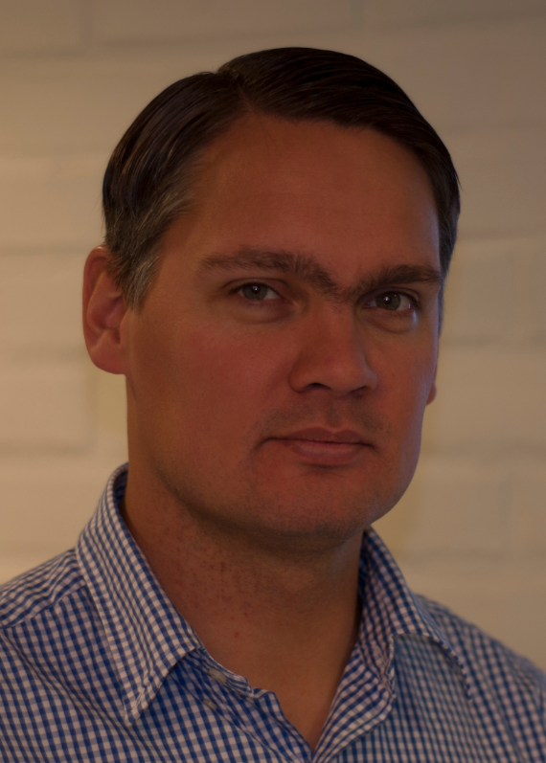
Björn Johansson – Curriculum Vitae
Name: Björn Johan Ingemar Johansson Date of birth: 28 November 1975
Place of birth: Gothenburg, Sweden Nationality: Swedish
Work address: Chalmers University of Technology, PPD, SE-412 96 Gothenburg, Sweden
Phone: + 46-31 772 38 09 E-mail: Bjorn.Johansson@chalmers.se
Family: Married to: Louise, Teacher, Ale Municipality
Children: Felicia (Born 2000, not biological father), Alice (Born 2005), Lilly (Born 2007)
Home address: Rosengången 9, SE-449 33 Nödinge, Sweden
Phone: + 46-303 965 47

Current position
Associate Professor, Vice Head of Division, Division of Production Systems, Department of Product and Production Development, Chalmers University of Technology, Gothenburg, Sweden

Academic qualifications
Associate Professor (tenure), Dept. of Product and Production Development, Chalmers | 06.2011 - present
Assistant Professor (non tenure), Dept. of Product and Production Development, Chalmers | 05.2006
Doctor of Philosophy, Production Engineering, Chalmers | 05.2006
Licentiate of Engineering, Production Engineering, Chalmers University of Technology | 10.2002
Master of Science, Mechanical Engineering, Chalmers | 04.2000

Professional experience
Guest Researcher at National Institute of Standards and Technology, USA | 10.2007-07.2010
Project Assistant, Dept. of Product and Production Development, Chalmers | 07.2005-05.2006
Project Assistant, Dept. of Materials and Manufacturing Engineering, Chalmers | 01.2005-06.2005
Project Assistant, Institute for Management of Information and Technology | 01.2005-06.2005
Guest Researcher, Production Modeling Corporation, Dearborn, Michigan, USA | 11.2004-02.2005
Managing Director, Production Modeling Corp Europe AB | 2003 - present
Lecturer, Dept. of Product and Production Development, Chalmers | 01.2002-04.2002
PhD student, Dept. of Product and Production Development, Chalmers | 02.2000-12.2004

Conference Arrangements
Appointed General Chair IEEE -Winter Simulation Conference, approximately 900 attendees. | 2018
Main organizer for IMS Horizon Workshop in Gothenburg, 55 attendees from 14 countries | 2012
Track Coordinator for Networks at Winter Simulation Conference  7 sessions with 30 reviewed papers and 21 accepted papers. | 2011
Lead Editor and member of the conference committee for Wintersimulation conference 408 submitted papers and approximately 800 attendees | 2010
Co. Editor and member of the conference committee for Wintersimulation conference 439 submitted paper, 315 accepted and approximately 800 attendees | 2009
Panel Discussion on how to incorporate and represent sustainability measures when evaluating production systems performance at Performance Metrics for Intelligent Systems (PerMIS09) | 2009
Panel Discussion on how to achieve a sustainable food production (FOODSIM 2008) | 2008
Track Coordinator for Manufacturing Applications at Wintersimulation Conference.  9 sessions with 40 reviewed papers and 27 accepted papers. | 2008
Participating in preparing national conference “Swedish production symposium” | 2007
Track Coordinator for Simulation based Scheduling at Wintersimulation Conference.  5 sessions with 27 reviewed and 15 accepted papers. | 2007
Panel Discussion on how to teach M.Sc. students Discrete Event Simulation at WSC | 2005

Numerous session organizations and sessions chaired as conferences such as Swedish Production Symposium, INFORMS conferences, Winter Simulation Conference, SCS, Eurosim, Foodsim etc…

Review activities

Review for selected scientific journals
The Arabian Journal for Science and Engineering | 2011 – present
International Journal of Sustainable Engineering | 2010 – present
Journal of Industrial Ecology | 2009 – present
Simulation: Transactions of the Society for Modeling and Simulation International | 2008 – present
International Journal of Innovational Computing & Information Control (IJICIC) | 2006
Appointments and memberships

Director at large, The Society for Modeling & Simulation International (SCS) | 2013 - 2016
Editor, Wintersimulation conference | 2009 & 2010
Member of Simulation Interoperability Standards Organization (SISO) | 2008 - present
Academic Director, Cluster Virtual Manuf.& Manuf. Data Mgt. -FFI | 2008 – 2010
Track coordinator, Wintersimulation conference | 2007 & 2008
Vice Director of the Board, special interest group Product Models (SIG-PM) | 2008 - present
Co-Director of the Board, special interest group Product Models (SIG-PM) | 2007
Member of the Board, special interest group Product Models (SIG-PM) | 2006 - present
Member, Sim-Serv association | 2003 - present
Member, The Society for Modeling and Simulation International (SCS) | 2003 - present
Member, INFORMS | 2002
Member of Swedish Manufacturing Simulation Network (SMSN) | 2001 - present

Scholarships granted

Klassen för Tekniska Vetenskaper, Kungl. Vetenskapsakademien | 2004
C-SELT | 2004
Alde Nilsson ABB | 2003
Ernst Gerbers Jubileumsfond | 2003
Chalmerska Stiftelsen | 2002

Reviews for selected scientific conferences
SIMULTECH | 2011 – present
NORD-PLM | 2008 – present
FOODSIM | 2008 – present
Middle Eastern Simulation Multiconference (MESM) | 2007 – present
Swedish Production Symposium (SPS) | 2007 – present
Eurosim congress on modeling and simulation (ESM) | 2007 – present
Industrial Simulation Conference (ISC) | 2006 – present
European Conference on Modelling and Simulation (ECMS) | 2004 – present
Winter Simulation Conference (WSC) | 2003 – present

Supervision activities
Supervision of doctoral candidates
Name | Role | Start | End | Degree | Topic
PhD Anders Skoogh | M | 060401 | 111203 | PhD | Input Data Management for Discrete Event Simulation
PhD Student  Erik Lindskog | E/M | 110601 | 131204  160601 | Licentiate  PhD Plan | Visualization of Virtual factory analysis
PhD Student  Jon Andersson | E/M | 110601 | 131204  160601 | Licentiate  PhD Plan | Environmental footprint calculations using Discrete Event Simulation
PhD Student  Jonatan Berglund | A | 120901 | 170901 | PhD plan | 3D-representation of factory data
PhD Guodong Shao | I | 080101 | 2013 | PhD | Interoperability for Discrete Event simulation analysis
PhD Student  Rolf Berlin | I |  | Year 2014 | PhD plan | Utilizing Scan data for sustainable measures in Production systems

E – Examiner M – Main Supervisor A – Assisting Supervisor I – Informal Guidance
Björn did examine additionally over 100 MSc/Master students in related areas, as well as partakes in main courses at production systems at Chalmers where simulation and sustainability is in core focus. Björn is also involved in PhD grading committee work, Licentiate discussion leader and EU project reviewer yeatly.

Project Coordination
Björn Johansson is and has been coordinator of several Work packages under VINNOVA and SSF projects such as Digital Factory Building Blocks (FFI), Factory in a Box (ProViking) & Conceptual Factory Design (MERA). Björn Johansson is the coordinator for EcoProIT (SSF ProViking project, 4 million SEK over 3 years.) and was Coordinator for the SYMBIZ (VINNOVA 0,5 million SEK over 0,5 years.) project. Björn Johansson is also coordinating Virtual Production Systems group under sustainable production initiative at Chalmers (VINNOVA, strategic funds 10 million SEK over 5 years.).Björn Johansson is coordinating Cluster 4 (1 million Euro) in Use-It-Wisely FP7 EU project (8,5 million Euro over 3,5 years).

Scientific publications

(Selection from 2009-2012, see http://publications.lib.chalmers.se/cpl/lists/publications/people/html/index.xsql?ids=7214 for complete list)

Selected Journals

Jain, S., Lindskog, E., Andersson, J. & Johansson, B. 2013. A Hierarchical Approach for Evaluating Energy Trade-offs in Supply Chains. International Journal of Production Economics .
Mani, M., Johansson, B., Lyons, K., Sriram, R. & Ameta, G. 2013. Simulation and analysis for sustainable product development. The International Journal of Life Cycle Assessment 18, nr. 5, s. 1129-1136.
Thiede, S., Seow, Y., Andersson, J. & Johansson, B. 2013. Environmental aspects in manufacturing system modelling and simulation – State of the art and research perspectives. CIRP Journal of Manufacturing Science and Technology 6, nr. 1, s. 78-87.
Johansson, B., Dagman, A., Rex, E., Nyström, T., Knutson Wedel, M., Stahre, J. & Söderberg, R. 2012. Sustainable Production Research: Awareness, Measures and Development. International Journal of Sustainable Development 4, nr. 11, s. 95-104.
Skoogh, A., Johansson, B. & Stahre, J. 2012. Automated input data management: evaluation of a concept for reduced time consumption in discrete event simulation. SIMULATION 88, nr. 11, s. 1279-1293.
Skoogh, A., Perera, T. & Johansson, B. 2012. Input data management in simulation - Industrial practices and future trends. Simulation Modelling Practice and Theory 29, s. 181-192.
Lee, Y-T. T., Riddick, F., and B. Johansson. 2011. Core Manufacturing Simulation Data – a manufacturing simulation integration standard: overview and case studies. International Journal of Computer Aided Manufacturing, 24 (8) pp. 689-709. ISSN 1362-3052.
Skoogh, A., Johansson. B. 2009. Mapping of Time-Consumption During Input Data Management Activities. Simulation News Europe, 19(2):39-46.

Selected book chapters & Peer reviewed conference proceedings

Lindskog, E., Berglund, J., Vallhagen, J. & Johansson, B. 2013. Visualization Support for Virtual Redesign of Manufacturing Systems. Forty Sixth CIRP Conference on Manufacturing Systems 2013
Sigurðardóttir, S., Johansson, B., Margeirsson, S. & Viðarsson, J. 2013. Assessing the impact of policy changes in the Icelandic cod fishery using a hybrid simulation model. International Conference on Simulation and Modeling Methodologies, Technologies and Applications
Andersson, J., Skoogh, A. & Johansson, B. 2012. Evaluation of methods used for life-cycle assessments in Discrete Event Simulation. Proceeding of Winter Simulation Conference 2012
Andersson, J., Skoogh, A., Berglund, J. & Johansson, B. 2012. Environmental Impact Assessment for Manufacturing: Data Requirements for a Simulation-Based Approach . Swedish Production Symposium
Andersson, J., Johansson, B., Berglund, J. & Skoogh, A. 2012. Framework for Ecolabeling using Discrete Event Simulation. Proceedings of the 2012 spring simulation multiconference
Faure, L., Koochakan, A., Berglund, J., Lindskog, E. & Johansson, B. 2012. 3D Movie Creation from Discrete Event Simulation Software Models of Manufacturing Industries. International Conference of Modeling, Optimization and Simulation
Jain, S., Lindskog, E. & Johansson, B. 2012. Supply Chain Carbon Footprint Tradeoffs Using Simulation. Proceedings of the 2012 Winter Simulation Conference
Johansson, B., Andersson, J., Lindskog, E., Berglund, J. & Skoogh, A. 2012. Evaluation and Calculation of Dynamics in Environmental Impact Assessment. Advances in Production Management Systems
Lindskog, E., Berglund, J., Vallhagen, J., Berlin, R. & Johansson, B. 2012. Combining Point Cloud Technologies with Discrete Event Simulation. Proceedings of the 2012 Winter Simulation Conference
Skoogh, A., Johansson, B. & Williams, E. 2012. Constructive Alignment in Simulation Education. Proceedings of the 2012 Winter Simulation Conference
Andersson, J., Skoogh, A., and B. Johansson. 2011. Environmental Activity Based Cost using Discrete Event Simulation. In Proceedings of the 2011 Winter Simulation Conference
Johansson, B., Jonsson, C., Felix, J., and A. Sundelin. 2011. Sustainable Production by Integrating Business Models of Manufacturing and Recycling Industries. In proceedings of the 18th CIRP International Conference on Life Cycle Engineering. s. 723. ISBN 3642196918.
Lindskog, E., Lund, L., Berglund, J., Lee, Y-T. T., Skoogh, A., B. Johansson. 2011. A Method for Determining the Environmental Footprint of Industrial Products Using Simulation. In proceedings of the 2011 Winter Simulation Conference. pp. 2136-2147

