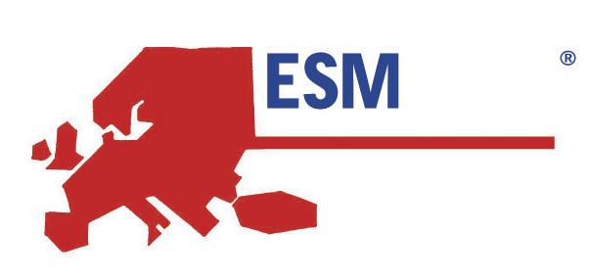  2006 |   IBIS Centre | 
TOULOUSE, OCTOBER 23RD – 25TH 2006
MR/MRS

FIRST NAME__________________________NAME_______________________________________

ADDRESS__________________________________________________________________________

________________________________________________________________________________

________________________________________________________________________________

ZIP CODE__________________CITY_________________________COUNTRY_________________

TELEPHONE___________________________ FAX ________________________________________

EMAIL: ____________________________________________________________________________
HOTEL ACCOMMODATION FAX REGISTRATION FORM
(Price are per room and night including breakfast and taxes), Deadline for reservation October 15th. 2006
TICK | HOTEL
[ ] | IBIS Centre **  2, rue Claire-Pauilhac, Toulouse  tel: +33 (0)5 61 63 61 63  fax +33 (0)5 61 63 07 46 | Monday-Thursday €73  Friday-Sunday € 55

Reservation needed of _________ room / s ____ single/s ____ double /s

Arrival date ________________ Departure date ___________________

Estimated Time of Arrival: ________
In order to ensure your room reservation a one night deposit will be required: €_________

TOTAL PAYMENT €________________DUE

PAYMENT BY
Credit Card:
 VISA  EURO/MASTERCARD  AMEX  DINERS CLUB

nº ___________________________________ Expiry date________/______

__________________________________ __________________________________
SIGNATURE PRINT SIGNATURE

Date__________________________

