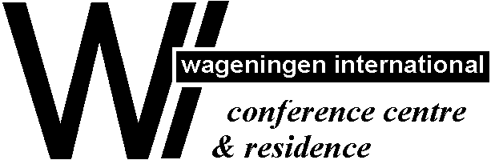
WICC-hotel WIR-hotel
Lawickse Allee 9 Stadsbrink 1
6701 AN Wageningen, 6707 AA Wageningen,
The Netherlands The Netherlands
Telephone 00 31 317 490133 Telephone 00 31 317 490122
Fax 00 31 317 426243 Fax 00 31 317 424332
reception@wicc-wir.nl reception@wicc-wir.nl
www.wicc-wir.nl www.wicc-wir.nl

How to reach the WICC- or WIR-hotel
By Car:
Coming from Arnhem/Nijmegen (=Motorway A50):
Take exit “Renkum/Wageningen/Oosterbeek”. At the traffic light take direction Renkum/Wageningen (N225). Go straight on till you come to a roundabout. At the roundabout go so straight on, and you will enter Wageningen.

For WICC : At the 4th traffic light turn left (=”Stationstraat”). Take the first turn to the right (=”Plantsoen”).
At the end of this road follow the curve and at the crossing (without traffic lights) turn right. At the
traffic light turn right again (= direction Renkum (N 225): “Lawickse Allee”). After 10 metres take
the road parallel to the main one. After 75 metres at your right hand you will see the parking lot of
the WICC.
For WIR : At the 4th traffic light turn right (=”Rooseveltweg”). Take the first street right again
(=”Stadsbrink”). On your right hand side you will see the parking of the WIR hotel.

Coming from Utrecht/Ede/Apeldoorn (=Motorway A12):
Take exit “Wageningen/Ede/Bennekom”. At the end of the exit go direction Wageningen (=”Dr. Dreeslaan”).
In Wageningen turn right at the first traffic light (=”Nijenoord Allee”) follow this ring road direction Rhenen.
At the 3rd traffic light (you will see the Agro Business Park in front of you) turn left (=”Kortenoord Allee”).
At the 1st traffic light, after roundabout, turn left (N225), direction Renkum (=”Lawickse Allee”).

For WICC :After 10 metres take the road parallel to the main one. After 75 metres at your right hand you will
see the parking lot of the WICC.
For WIR :At the next traffic light turn left (=”Rooseveltweg”) and take the fist street right (=”Stadsbrink”).
On your right hand side you will see the parking of the WIR hotel.

Coming from Rotterdam/Breda (=Motorway A15)
Take exit “Ochten/Kesteren”. Immediately after the exit turn left (follow N233, Rhenen). Over the bridge at Rhenen (river Rhine) turn right (follow N225, direction Wageningen/Renkum). After approximately 6 kilometres at the roundabout straight on (N225).

For WICC : After the roundabout and the traffic light, take the road parallel to the main one. After 75
metres at your right hand side you will see the parking lot of the WICC.
For WIR : At the 2nd traffic light, turn to the left (=”Rooseveltweg”), and take the first street right
(=”Stadsbrink”). On you right hand side you will see the parking of the WIR hotel.

By Public Transport:
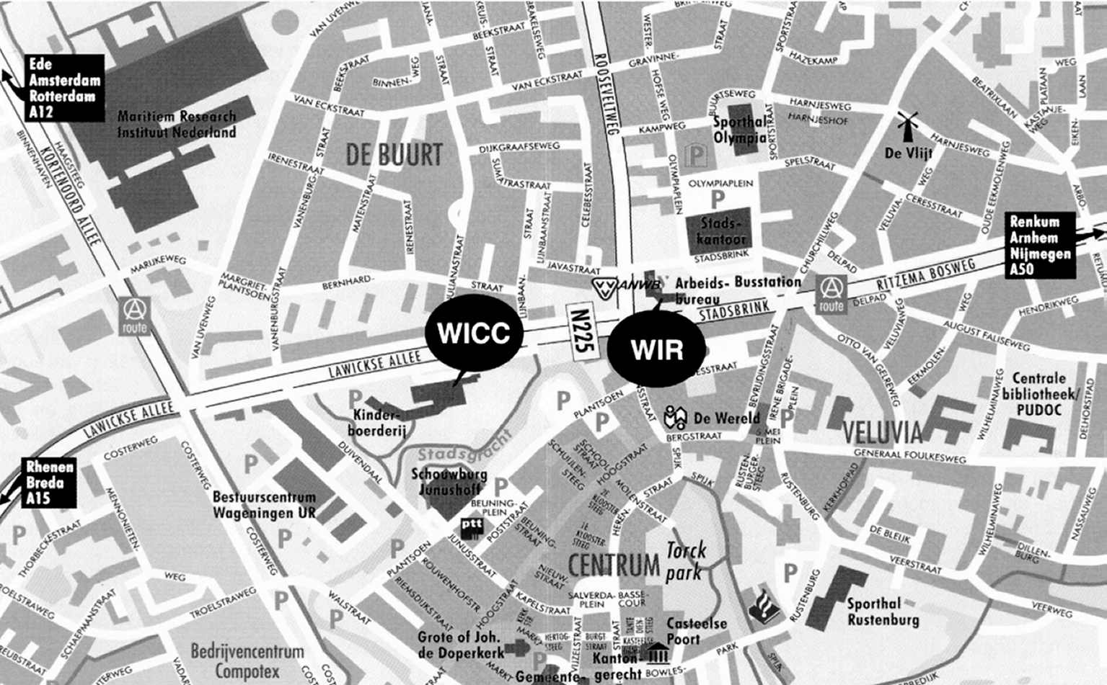
From “Ede-Wageningen” railway station you can take a “TREIN TAXI” (till 01 April 2004) or take the bus to Wageningen bus terminal. The WIR-hotel is situated next to the bus terminal and the WICC-hotel app. 250 meters to the west.

230304

